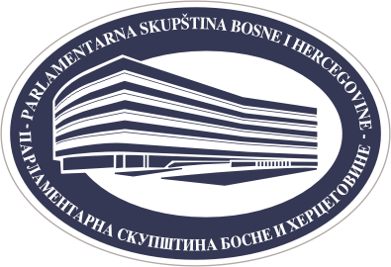

PARLIAMENTARY ASSEMBLY OF BOSNIA AND HERZEGOVINA
PUBLIC RELATIONS SECTOR
www.parlament.ba ● e-mail: press@parlament.ba
phone: +387 33 284 441
phone/fax: +387 33 284 447

ANNOUNCEMENT FORM FOR THE GROUP VISIT TO THE PARLIAMENTARY ASSEMBLY OF BOSNIA AND HERZEGOVINA

Organisation/ institution :
Adress:

Contact person:
Phone:
e-mail:

Preferred date of the visit: | Date: |  | Time:
Alternative date of the visit: | Date: |  | Time:

The areas that we are particularly interested in are: | - ALL  - Legislative  - Work of the houses  - Work of the committees and caucuses  - MP´s work  - Euro-Atlantic integration process  - Parliamentary building  - Transparency of the work
We are interested in meeting with MP´s YES NO

NOTICE:
- After submitting this form, the precise date of the visit is necessary to refine with the Public Relations Sector
- The preferred deadline for the submission of this application is no later than seven (7) days prior to the preferred date. We expect the list of visitors no later than 48 hours before the specified term of the visit.

